Tasks

1. Write a program to declare an integer, a pointer to that integer and demonstrate the use of pointer to modify the value of the integer.
2. Write a program to declare an integer variable, and a pointer to that integer.
3. Write a program that takes two pointers and swaps by using pass by reference.

TASK 1!

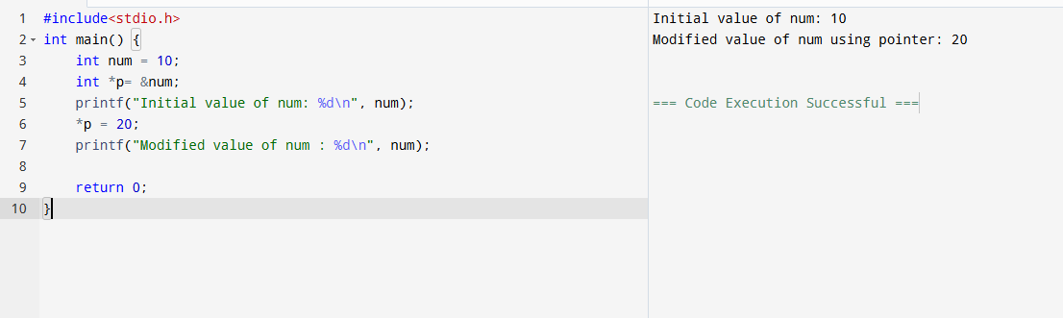

TASK 2!

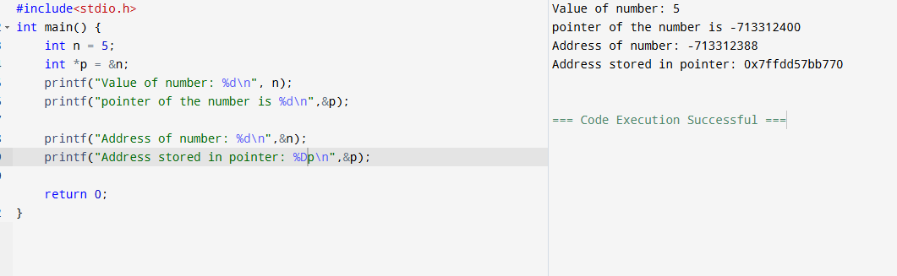

TASK3!

